Unity Scene Set Up Instructions:

Main Camera must have the MaxCamera script attached. All variables are provided with default values but they can be set in the inspector, and via the GUI.

The Script LoadInText must be attached to an empty GameObject. With this GameObject selected, you can provide values in the inspector.

You can use the prefabs provided for you, LungTissue and TargetTissue. Organ data can be provided in the Filenames section, which requires the filepaths for text files. The text files should contain comma-separated

(x,y,z,dose) values, with a line break after each dose. Eg:

100, 500, -1, 0.0112

120, 510, -2, 0.0223

...

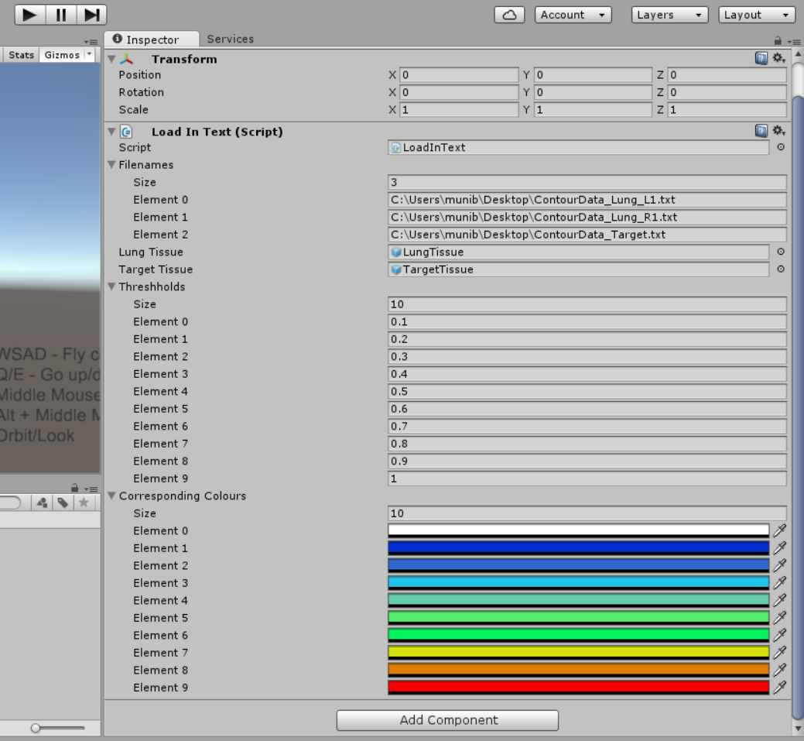

Figure : Inspector tab, with the LoadInText GameObject selected

You should also see a Thresholds menu and a Corresponding Colours menu. Set these both to be the same size. You can now set radiation dose thresholds and their corresponding colours. For instance, in the example above, any part of the organ with a radiation dose of less than 0.1 will be coloured white. Make sure to order the Thresholds in ascending order.